Salesforce Administrator Self-Learning & Super Badges

SALESFORCE ADMINISTRATOR - SELF LEARNING

sub heading:- Sales Cloud Basics

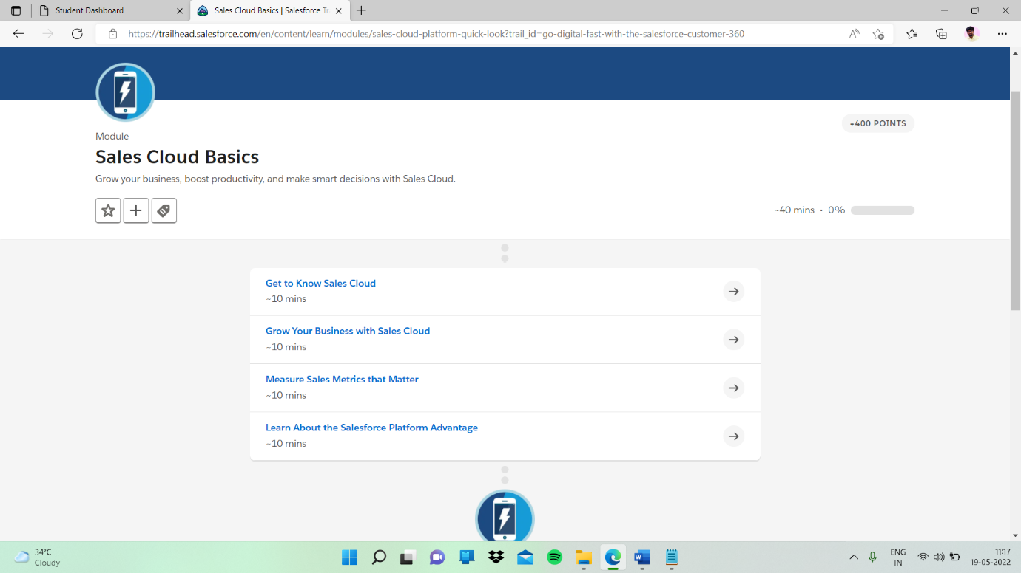

Sub topic:- Get to Know Sales Cloud

In this I taken quiz and I completed in cloud how to store sales stock lot if things

